**PRIMARY FIVE TERM I**

**SCIENCE**

**WEEK TWO**

**LESSON 1AND 2**

**TOPIC ONE: KEEPING POULTRY**

**Terms used in poultry and their meanings**

* + **Hen**– Adult female chicken.
  + **Cock** – Adult male chicken.
  + **cockerel** – Young male from 8 weeks on wards
  + **capon** – castrated male
  + **pulle**t – young female
  + **chick** – very young bird from hatching to 8 weeks
  + **Incubation** – process by which an egg is given necessary condition to hatch into a chick
  + **Incubator** – A machine used to hatch eggs into chicks
  + **Layer** – Type of bird kept mainly for egg production
  + **Broiler** – This is a type of chicken kept mainly for meat production.
  + **Brooding** – It is the giving of special care to young chicks below 8 weeks.
  + **Broody hen** – A hen sitting or incubating eggs to hatch them.
  + **Brooder** – A special structure for keeping chicks below 8 weeks
  + **Culling** – This is the removing of unwanted chicken e.g. sick or un productive birds from the flock.
  + **Moulting** – The process by which birds shed their feathers to replace them

**TOPIC ONE: KEEPING POULTRY**

**Poultry:** Poultry refers to domestic birds

**Types of poultry/examples of poultry**

* Chicken
* Ducks
* Turkeys
* Pigeons
* Guinea fowls

**Poultry keeping:** This is the rearing of domestic birds.

* + 1. **Importance of poultry keeping**
* For meat production
* For egg production
* Source of income when sold.
* Their droppings are used as manure.
* Some birds are kept as pets.

NB: Their eggs and meat are sources of proteins to our bodies

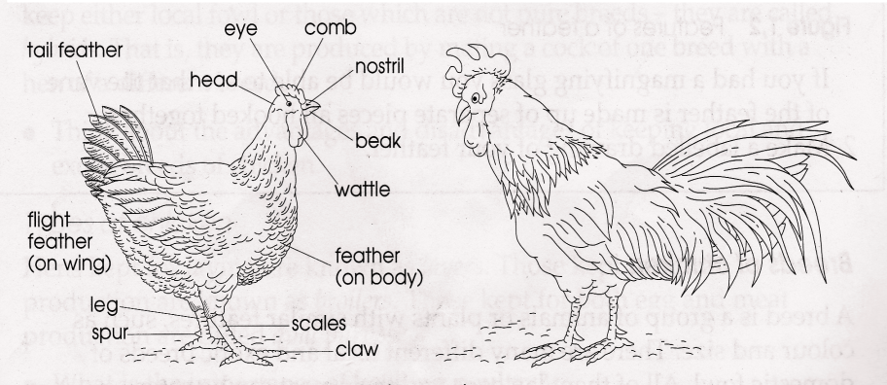(f) **External features of a domestic bird**

(g) **Functions of each part**

* + **Beak** – picks up food
  + **Nostrils** – They are sense organs for smell
  + **Eyes** – Enable birds to see
  + **Wings** – Enable birds to fly
  + **Claws** – for scratching the ground to look for food
  + **Spur** – For protection

- Firm grip during mating

Feathers are the outermost covers of the bird’s body.

**Uses of feathers to birds**

* + Keep the bird warm.
  + Protect their body from mechanical injury
  + Enable birds to fly
  + Give shape and colour for easy identification
  + For attraction to opposite sex during mating period

**Uses of feathers to people**

* For decoration
* For making pillows
* For making mattresses

**Differences between a hen and a cock**

**Cock** **Hen**

- Has a big comb - Has a small comb

- It has a long spur - Has a short spur

-Has shiny nape -Has dull nape

-Has long tail feathers -Has short tail feathers

- Has a big wattle - Has a small wattle

**LESSON ACTIVITY ONE**

1. Define the term poultry.

2. Name any two types of poultry apart from chickens.

3. What is meant by the term poultry keeping?

4. Give two reasons why people keep poultry.

5. Name any one product got from poultry.

6. How are feathers useful to birds?

7. How is a spur useful to a cock?

8. How is a cock different from a hen?

9. How are feathers useful to people?

LESSON 3 AND 4

**Types of chicken**

A type of chicken is a class of chicken kept for specific purpose.

* + Broilers
  + Layers
  + Dual purpose chicken

(a) **Broilers (table birds)**

These are types of chicken kept mainly for meat production

**Examples of broilers**

* Ply mouth rock
* Light Sussex
* Rhode Island Red
* Black australop
* black giant
* Orpington

(b) **Layers (light breeds)**

These are a type of chicken kept mainly for egg production

**Examples of layers**

* White leghorn
* Ancona
* Minorca
* Brown egger
* Sykes

(c) **Dual purpose chicken**

These are a type of chicken kept mainly for both meat and egg production

**Example of dual purpose chicken**

* Rhode Island Red
* New Hampshire
* kroilers
* Black australorp

**ACTIVITY TWO**

1. Name the type of chicken kept mainly for meat production.

2. Why do poultry farmers keep layers?

3. Name any one breed of chicken kept mainly for egg production.

4. Give any two types of chicken

5. Why do some poultry farmers keep white leghorn?

LESSON 5 AND 6

**Breeds of chicken**

A breed of chicken is a group of chicken with similar characteristics

**Breeds of chicken include:**

* White leghorn
* Ancona
* Light Sussex
* Minorca
* Sykes

**Types of breeds of poultry**

* Local breeds
* Exotic breeds
* Cross breeds

1. **Local breeds**

They are sometimes referred to as indigenous or native breeds

They are called native or local because they existed in Uganda for a very long time.

**Characteristics local breeds**

* + They are more resistant to diseases and parasites
  + They grow slowly
  + They lay small and few eggs
  + They can withstand bad weather conditions.
  + They produce less meat
  + They have different colours

**How to improve upon the local breeds of poultry**

* + By carrying out cross breeding.

(b) **Exotic breeds**

* + These are breeds which were imported into Uganda from other countries e.g white leghorn, Rhode Island red and light Sussex etc

**Characteristics of exotic breeds**

* + They are less resistant to parasites and diseases
  + They grow and mature faster.
  + They laymanyeggs
  + They have the specific colour.
  + They produce a lot of meat

**Advantages of local breeds over exotic breeds**

* + Local breeds are more resistant to disease than exotic breeds.

**Advantages of exotic breeds over local breeds**

* + They grow and mature faster than local breeds.
  + They lay more eggs than local breeds
  + They produce much meat than the local breeds

1. **Cross breeds**

These are types of breeds got by mating exotic breeds with local breeds.

**Examples of cross breeds**

* Shavers
* Ross birds
* Sterling

**Advantages of cross breeds over local breeds**

They produce much meat than local breeds

They grow and mature faster than local breeds

**Advantages of cross breeds over exotic breeds**

They are fairly resistant to diseases than exotic breeds

**ACTIVITY**

* State any one characteristics of exotic breed of chicken.
* Why do some people prefer local breeds of chicken?
* How can poultry farmers improve on the quality of their local breeds?
* Why do some farmers prefer rearing exotic breeds of chicken?
* Name any two breeds of chicken.
* Why wouldn’t you rear exotic breeds of chicken?
* Why wouldn’t you rear local breeds of chicken?

WEEK THREE

LESSON 7 AND 1

**Systems of keeping birds**

* Free range system
* Deep litter systems
* Battery system
* Fold system

(a) **Free range system (Extensive)**

This is a system where the birds are left to move freely to look for food.

This system of poultry keeping is very common in rural areas where land is in plenty.

**Simple diagram to illustrate a free range system**

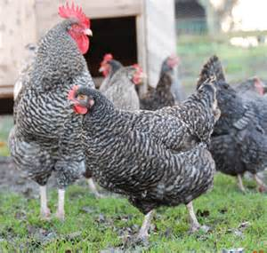

**Advantages of free range system**

* + Birds get balanced diet
  + Birds get enough physical exercise
  + Manure is well spread in the field
  + It is cheap in terms of feeding
  + It is time saving since the birds need little care
  + It is easy to control the poultry vice

**Disadvantages of free-range system**

* + It is difficult to keep records
  + It requires a very big piece of land
  + The poultry may easily destroy farmers’ crops
  + It’s hard to collect the eggs.
  + There is easy spread of disease in poultry
  + Birds can easily be stolen or eaten by predators

1. **Deep litter system**

This is a system of rearing a big number of birds under one shelter.

N.B: The house where such a practice is carried out is called **a deep litter house**

The floor of this house is covered with **litter**

Deep litter system is carried by commercial farmers

**Materials used as litter**

* Coffee husks
* Crushed maize cobs
* Wood shavings
* Dry grass

**Importance of litter**

* It keeps the floor of a deep litter house warm and dry
* It absorbs moisture from poultry droppings

**A diagram to illustrate deep litter system.**

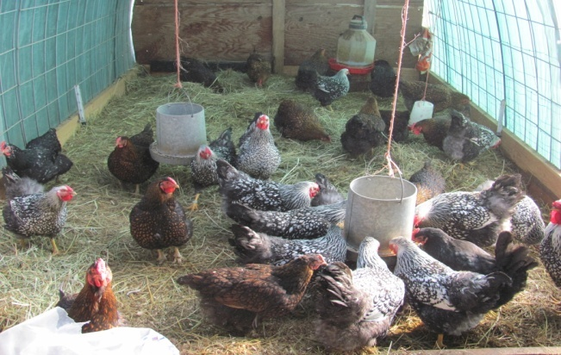

**Advantages of deep litter system**

* + Collection of eggs is easy
  + Many birds are kept in a small area
  + It is easy to feed birds in one place
  + Birds are protected from predators
  + Record keeping is easy
  + Birds cannot easily pick parasites
  + Chances of disease spread are reduced
  + It is easy to collect manure

**Disadvantages of deep litter system**

* + It is expensive to start and maintain the system
  + Much attention and care is needed
  + If litter stays for long it produces bad smell
  + It is tiresome to look after the birds
  + Vices such as egg eating, cannibalism, etc. may be developed by birds
  + Birds may not get enough exercise
  + Comfortable litter may lead the birds to become broody.

**ACTIVITY**

* Name any two systems of rearing poultry.
* Write any two advantages of free range system of rearing poultry.
* Give any one disadvantage of free range system of keeping poultry.
* Why is free range system commonly used in villages?
* Name the system of rearing chicken where birds are kept indoors.
* Mention one advantage of deep litter system.
* How is litter important in a poultry house?
* Name one material used as litter in poultry house.
* Identify any one system of keeping poultry for commercial purpose.

LESSON 2 AND 3

(c) **Battery (cage) system**

In this system, birds are kept in separate cages (one or two)

The floor slopes slightly so that when eggs are laid they roll into a wire trough

Droppings fall under raised cage and make the floor remain clean

**Advantages of battery (cage) system**

* + Food, water and eggs are hardly contaminated
  + Sick birds can be easily detected and removed.
  + Many birds can be kept on a small piece of land
  + Eggs laid remain clean
  + It is very easy to identify poor layers.
  + Birds are protected from predators
  + Poultry vices are reduced
  + It is easy to collect manure
  + Record keeping of individual birds easy
  + Diseases and parasites do not spread easily

**Disadvantages of battery (cage) system**

* + It is very expensive (cages are expensive to construct)
  + Birds may not get a balanced diet
  + Much labour is needed
  + Birds do not get enough exercise

1. **Fold or pen system**

In this system, birds are kept in a small structure called a fold or pen or ark

The fold or pen the birds are moved to new places daily.

The fold or pen provides shade and egg laying space for birds.

**A simple structure of fold or pen**

**Advantages of fold or pen system**

* + Birds are restricted and cannot destroy crops
  + Chickens feeds are not wasted
  + Manure is well spread on the farm
  + Chickens are safe from predators
  + Feeding is cheaper and birds get a balanced diet

**Disadvantages of fold or pen system**

* + It needs a very big piece of land.
  + Folds get old quickly due to frequent movement
  + More labour is needed to move folds every day
  + It is not applicable on hilly and swampy areas
  + It is very expensive to construct fold
  + Only few birds are kept
  + Birds do not get enough exercise

**Simple diagram of alimentary canal**

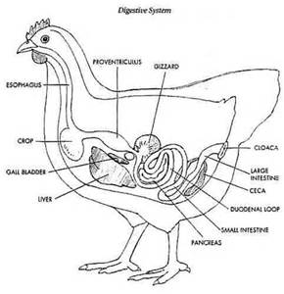

**The digestive systems of a bird (Alimentary canal)**

* + The digestive system of a bird (alimentary canal) consists of the following major parts namely; Beak, Gullet, crop, stomach, small intestine, large intestine, caeca, Gizzard and cloaca (vent), Beale

**Functions of each part**

(a) **Beak –** It picks food

(b) **Gullet –** It is a food passage to the crop

(c) **Crop –** It stores, moisture and softens the food before it goes to the stomach

(d)**Stomach-** it is where food is mixed with digestive juices.

(e) **Gizzard –** In this organ, food is crushed into small particles to help small stones called **grit or pebbles**

(f) **Small intestines –** Digestion of food is competed here and digested food is absorbed into blood stream

(g) **Large intestines** – absorption of water from undigested food takes place here.

(h) **caeca-** digestion of roughage takes place here by the help of useful bacteria

(i) **Cloaca (vent) –**it is a passage of eggs and droppings at different times.

**ACTIVITY**

1. Give any two advantages of cage system.
2. Why is cage system commonly used in urban areas.
3. Give one disadvantage of cage system.
4. How is the beak useful to a bird?
5. Give one use of the crop to domestic bird.
6. How useful is grit in the gizzard of a domestic bird?
7. Why are small stones added in poultry feeds?
8. Name the part of the digestive system of a bird where digestion ends.
9. Name the part of the digestive system of a bird where food is mixed with digestive juices.

**LESSON 4 AND 5**

**Reproduction in poultry**

Poultry reproduce by laying eggs

**An egg (fully grown/developed)**

* + The structure of an egg consists of the following parts; Egg shell, shell membrane, air space, albumen (egg white), chalaza, embryo or germinal disc

**Cross section through an egg**

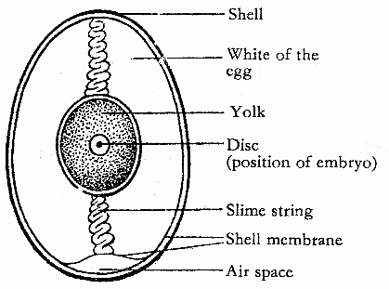

**Functions of the parts.**

**Egg shell**: protects the inner part of an egg.

It is porous to allow gaseous exchange.

**Air space**: It stores air

It provides oxygen to the embryo.

**Egg Yolk**; provides food to the growing embryo.

**Germinal disc:** develops into a chick.

**Albumen or egg white;** Provides food to the growing embryo.

**Chalaza;** holds the Yolk and embryo in one position.

It transports oxygen to the growing embryo

**Factors that may lead fertilized eggs fail to hatch**

* If the egg has two yolks
* If the egg is cracked
* If the egg has a soft shell
* If the egg does not have the air space

**Incubation**- This is the process by which a fertilized egg is given necessary conditions to hatch into a young bird

**Conditions needed for eggs to hatch**

* Warmth
* Moisture

**Incubation period** – This is the time taken for a fertilized egg to hatch into a young bird

**Incubation period for different birds**

* Chickens – 21 days
* Ducks – 28 days
* Turkeys – 28 days or 4 weeks
* Pigeon – 14 days
* Geese – 30 days

**ACTIVITY**

1. How do birds reproduce?
2. give the use of the following parts of an egg.
3. egg shell
4. chalaza
5. air space
6. egg yolk
7. germinal disc

3. Why is the egg shell porous?

4. Give any two reasons why a fertilized egg may fail to hatch.

5. Name one condition needed by an egg to hatch.

6. What is the incubation period of the eggs of a hen?

**LESSON 6 AND 7**

**Types of incubation**

(a) **Natural incubation**

This is when a mother hen sits on her eggs to enable them hatch.

* The broody hen usually comes off to feed, gets little exercise and in the morning to wet its feathers to prevent heat loss and add moisture to the eggs during incubation

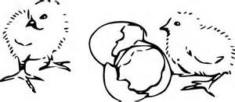**Diagram of a hen incubating eggs A chick hatching from an egg**

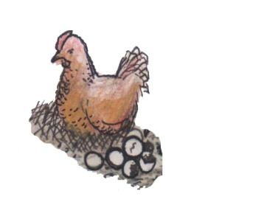

**How to ensure effective natural incubation**

* Use good fertilized eggs
* The place for incubation should be with dim light
* Protect the hen from rats, snakes etc which might eat eggs
* Provide a good, clean, dry nest that is comfortable for the broody hen

**Advantages of natural incubation**

* + - It is cheap and easy to manage
    - Chicks get extra care from the mother hen
    - Chicks get protection from the mother hen

**Disadvantages of natural incubation**

* + - Fewer chicks are hatched at a time
    - It can’t be used by commercial farmers
    - Eggs are not tested for their fertility
    - Some eggs are not hatched
    - Hens used may not be good for incubation
    - The birds can be attacked by snakes, wild cats and mites

**b) Artificial incubation**

This is a machine called incubator is used to hatch eggs

An incubator may provide all conditions that a broody hen provides

An incubator can use paraffin or electricity to provide enough warmth

A locally designed incubator uses paraffin and modern one uses electricity

**An incubator**

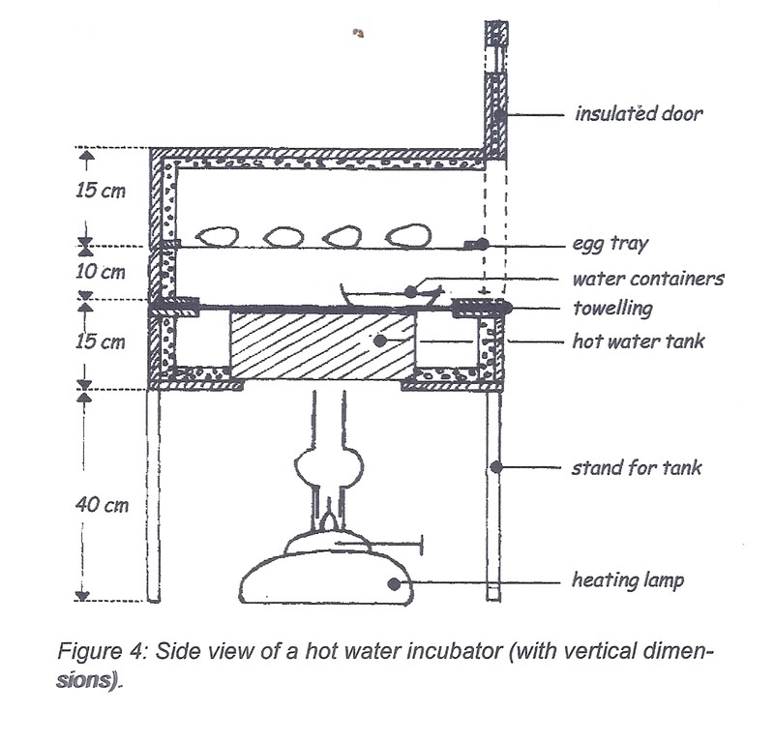

**Advantages of Artificial incubation**

* + - Very many eggs can be hatched at a time
    - It is good for commercial farmers
    - Eggs are tested for their fertility in the process called candling
    - Temperature is maintained properly in an incubator by the use of a thermometer
    - All eggs are hatched since they are first tested for their fertility

**Disadvantages of Artificial incubation**

* + - It is very expensive method of incubating eggs
    - It needs regular supervision
    - It needs skilled man power
    - It is tiring
    - Eggs can be affected in case of frequent black out or load shading

**ACTIVITY**

1. Give the meaning of the term incubation.
2. Identify the two methods of incubating eggs.
3. Mention any two advantages of natural incubation.
4. State two advantages of artificial incubation.
5. How is an incubator useful to a poultry farmer?
6. how do hens make use of beaks during incubation?

WEEK FOUR

LESSON 1 AND 2

**Brooding**

Brooding is a process of giving special care to chicks below 8 weeks

**Types of brooding**

* Natural brooding
* Artificial brooding

1. **Natural brooding**

This is a method where a hen takes more care of her chicks by providing warmth, security and food to them

Farmers may also support by providing more food and water to the mother hen and its chicks

When the chicks are big enough, they are left on their own

**A hen looking after her chicks**

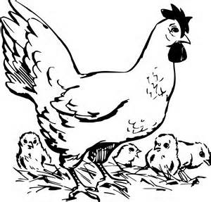

**Advantages of natural brooding**

* + The mother hen looks for food for its chicks
  + The mother hen provides security for its chicks
  + Toes and feather pecking are reduced among chicks

**Disadvantages of brooding**

* + Chicks may die due to poor protection
  + Chicks are exposed to predators
  + It is not carried out on large scale
  + It gives little profit
  + A mother hen may be stolen or eaten by predators leaving chicks without care

1. **Artificial brooding**

This is where by chicks are kept in a special structure called a brooder

**A brooder** is a special house /structure designed to keep chicks below 8 weeks

**Types of brooder**

(a) Infra – red brooder

(b) Kerosene brooder

**Infra – red brooder**

**Infra – red brooder:** In this type, electricity is used as a major source of heat

Lamps are hung from the ceiling and adjusted (changed) from time to time as chicks grow

**A simple diagram of infra-red brooder**

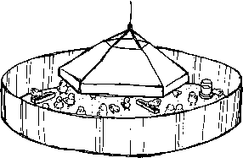

**Kerosene brooder**

In this type, farmers use paraffin lamps (lanterns) as sources of heat.

This type needs careful handling of lamps not to burn chicks and avoid accumulation of soot

The lamp should also be with guards to keep off chicks from being burnt

**A layout of kerosene brooder**

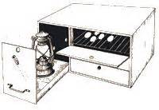

**Management practices**

* + Management practices are routine activities carried out on farm to increase on the quality of farm animals and their products

**Common daily/routine activities include**

* + Record keeping
  + Regular cleaning
  + Vaccination
  + De-worming
  + Culling
  + Dusting
  + Egg collection
  + Debeaking
  + Cross breeding
  + Housing
  + feeding

**ACTIVITY**

1. What is brooding?
2. name the two methods of brooding.
3. give any two advantages of natural brooding.
4. mention one disadvantage of natural brooding.
5. name any one advantage of artificial brooding.
6. state one disadvantage of artificial brooding.
7. give one way of caring for chicks in a brooder.

LESSON 3 AND 4

**Feeding poultry**

**Chicken mash**

* + Chicken are fed on different types of feeds called **mash.**
  + Chicken mash is grouped into four (4) types namely; chicken and duck mash, Growers mash, Layers mash and broilers mash

**Chick and duck mash**

* + It is given to chicks and ducklings which are 1 day – 8 weeks
  + This mash contains high protein content to support fast growth in chicks

(b) **Broilers mash**

* + It is prepared for chicken that provide meat (chicken)
  + It is introduced to broilers from 8 weeks on wards

(c) **Growers mash**

* + It is given to growing birds e.g. layers from 8 weeks to about 16 weeks (8 – 16) weeks and Broilers between 4 – 8 weeks

(d) **Layers mash**

* + It is prepared for laying chicken
  + It is introduced to layers at 16 weeks

**Summary table**

|  |  |
| --- | --- |
| **Mash** | **Bird’s age** |
| Chick and duck mash  Layers mash  Broilers mash | Chicks and ducklings of 1 day to 8 weeks (two months)  Layers from 8weeks – Broilers from 4-8 weeks  Broilers to 8 weeks on wards |

**Feeding tools**

* + The mash given to chicken must be always put in a clean containers called feeding troughs
  + A good feeding trough should be constructed with a spinning/rotating handle in the middle to prevent birds from stepping on and spoil or contaminate the mash

**Simple diagrams of feeding tools**

**Feeding trough**  **Drinking trough(conical drinker)**

Spinning/rotating handle chicken mash water conical

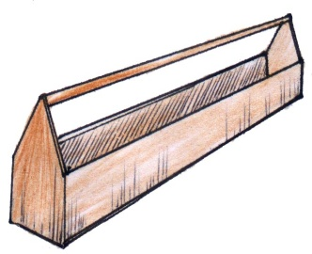Wooden feeding trough 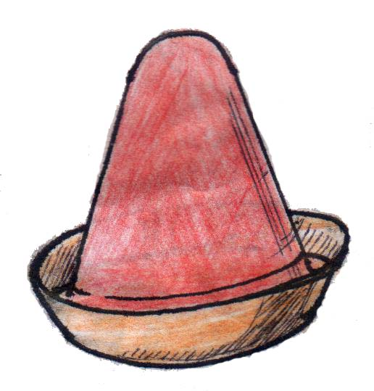

**Housing poultry**

**Qualities of a good poultry house**

* + It should be well ventilated to allow free exchange of gases
  + It should have enough light to enable the birds to see feeds and water
  + It should have enough space for the birds
  + It should have strong doors
  + Its roof should be leak proof
  + It should be free from dampness or moisture
  + It should be free from diseases and parasites etc

**ACTIVITY**

1. Name the food given to one day old chicks.
2. Give one reason why birds may lay eggs with soft shells.
3. Why are crushed snail shells mixed in poultry feeds?
4. Why are birds given water for drinking regularly?
5. Give the use of the following feeding tools
6. feeding troughs
7. drinking troughs

6. Why is a feeding trough made with a spinning handle?

**LESSON 5 AND 6**

**Poultry vices**

These are bad habits done by domestic birds

**Common poultry vices are**;

* Egg eating
* Feather pecking
* Cannibalism

**Causes of poultry vices**

* + Over-crowding of birds (too many birds in a small area)
  + Boredom among domestic birds
  + Poor feeding of birds
  + Failure to remove broken eggs from poultry house
  + Failure to collect eggs in time from the poultry house

**Prevention/control of poultry vices**

* + Carryout de-beaking
  + Collect eggs regularly from laying boxes
  + Putting laying boxes in dark corners
  + Proper feeding of birds
  + Putting perches in a poultry house
  + Hanging leafy vegetables from the poultry house

**Diseases and parasites of poultry**

**General causes of diseases and parasites**

* + Poor feeding of poultry
  + Poor housing structure for birds
  + Poor hygiene in the poultry house

**Dangers of diseases and parasites**

* + Death may occur
  + Lower the quality of products
  + Reduces the bird’s rate of growth

**Common diseases of poultry**

**Disease**  **cause**

* + Coccidiosis Protozoa
  + Newcastle virus
  + Fowl pox virus
  + Fowl typhoid bacteria
  + Avian leucosis virus
  + PneumoniaBacteria
  + Gumboro disease virus
  + Black head protozoa

**Pneumonia**

* + It is caused by bacteria
  + It attacks the lungs

**Signs and symptoms**

* + Difficulty in breathing
  + Coughing
  + Lack of appetite
  + Mucus from the nose

**Prevention and treatment**

* + Keep the poultry house clean
  + Make the house well ventilated
  + Separate diseased birds from healthy ones
  + Early Treatment with antibiotics

**Coccidiosis**

**-**It is caused by protozoa

**Signs of coccidiosis**

* Diarrhea
* Blood stained droppings
* Dullness and drooping of wings

**Prevention and control**

* Vaccinate the birds
* Use of coccidiostats in poultry feeds
* By culling infected birds

**Newcastle disease**

-It is caused by virus

**Signs of Newcastle disease**

* Greenish diarrhea
* Staggering
* Drooping of wings
* Bending of the neck
* Poor eggshell formation

**Prevention and controlNewcastle disease**

* Regular vaccination
* Kill and bury all the infected birds
* Disinfect the poultry house

**ACTIVITY**

1. What are poultry vices?
2. Give any two examples of poultry vices.
3. State any one cause of poultry vices.
4. Mention any two ways of controlling poultry vices.
5. Name any two poultry diseases caused by a virus.
6. Identify any one poultry disease caused by bacteria.
7. Name one disease that affects both rabbits and poultry
8. Why is debeaking practiced in poultry management?
9. Identify any one poultry disease caused by protozoa
10. Give one way of controlling diseases among poultry

LESSON 7

**Parasites** - These are living organisms which depend on other living organisms for food and shelter.

**Types of parasites**

* Ecto – parasites (External parasites)
* Endo – Parasites (internal parasites)

**Ecto parasites**

These are parasites which live on the body of a host

**Examples of ecto parasites of poultry**

Fleas, mites, lice

**Endo - parasites**

These are parasites that live inside the body of a host.

* + sCommon examples are: Round worm, Tape worm, Threadworm etc

|  |  |  |
| --- | --- | --- |
| Types of parasites | Examples | Effects |
| Ecto parasite | Fleas  mite  fowl lice | * They create wounds on skin of birds * They cause itching and scratching of body that may lead to loss of feathers * They suck blood from the birds making them anaemic * Egg laying is greatly reduced * Mites cause a disease called **mange** |
| Endo parasites | Tape worm  Round worm | * They cause stunted or poor growth * Egg laying is reduced |

**Control of parasites in poultry**

* + Use of pesticides for external parasites
  + Carry out regular deworming to kill internal parasites.
  + Clean poultry houses regularly.
  + Apply Vaseline jelly on affected parts of the body caused by mites and fleas
  + Give birds clean water and food
  + Give birds water and food in clean troughs

**Keeping farm records**

Farm records are written information showing activities carried out on a farm.

**Types of records**

* Health records
  + Feeding records
  + Production records
  + Breeding records
  + Sales and expenses records (expenditure) etc

**Importance of keeping records on a farm**

* + It helps the farmer to plan for his farm.
  + It helps the farmer to know profits or losses of the farm
  + Help a farmer to get loans from a bank easily
  + Help a farmer to be taxed fairly by government.

**ACTIVITY**

1. Name any two ecto parasites of poultry.
2. Give any one internal parasites in poultry.
3. How can internal parasites in poultry be controlled?
4. How can external parasites in poultry be controlled?
5. name any two types of farm records kept on a poultry farm.
6. give any two reasons for keeping farm records on a poultry farm.

WEEK FIVE

LESSON 1

**Keeping bees**

**Bee keeping:** is the rearing of bees.

**Apiculture**: is the rearing of honey bees on a large scale.

**Importance of bees to plants and people**

**People**

* + People get honey from bees
  + People get wax from bees.
  + Bee farming creates employment to people

**Plants**

* Bees help in pollination

**The life cycle of a honey bee**

* + The honey bee undergoes complete metamorphosis
  + The Queen lays eggs
  + The larvae are developed from the eggs and are fed by the worker bees
  + They change in pupae
  + The pupae develop into adult bees

**Simple diagram to illustrate**



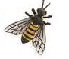

**ACTIVITY**

1. What name is given to a place where many bees hive with bees?
2. How are bees useful to plants?
3. Why do people keep bees?
4. Name any one bee product.
5. Why honey bees are called social insects?
6. Which type of life cycle do bees undergo?
7. What is meant by the term apiculture?

LESSON 2 AND 3

**Types of honeybees**

* + There are three types of bees in each colony namely;
    1. Worker bees (b) Drone bees and (c) Queen bees
       1. **Queen bee**
  + It is the head of the colony
  + The Queen bee is formed when female grub is fed on royal jelly throughout its life cycle.
  + Its main function is to lay eggs
  + It is a female fertile bee
  + It is the biggest in the colony
  + Its abdomen is longer than that of others
  + Its fed on special food by workers called **royal jelly**

**Simple diagram to illustrate**

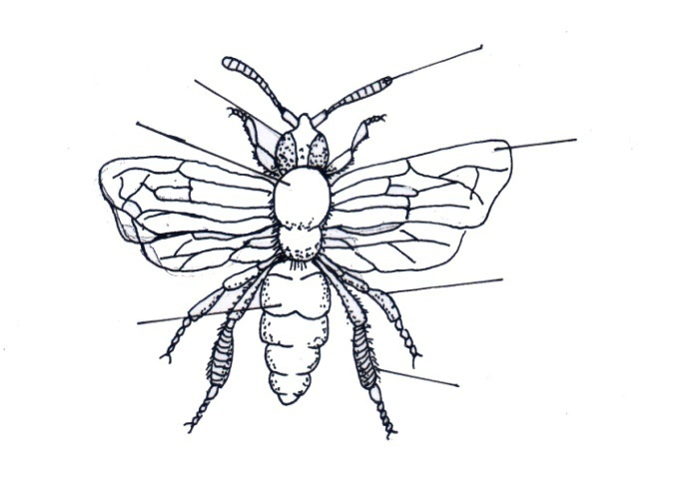

Wing

antenna

compound eye

thorax

abdomen

leg

1. **Worker bees**

* These are female sterile bees
* They are the smallest in the hive
* They have hair on the back and on their legs
* They have a sting
* They are many in the hive
* They have a sting at the end of their abdomen

**Roles of a worker (s) in the hive**

* It feeds the Queen bee on a special food called royal jelly
* It feeds the grub
* Protects the Queen and the hive
* They make honey
* They repair the hive
* They clean the hive
* They regulate temperature (They fun the hive)

**Simple diagram of a worker bee**

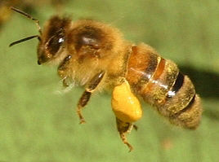

Diagram showing the parts of hide leg of a worker bee

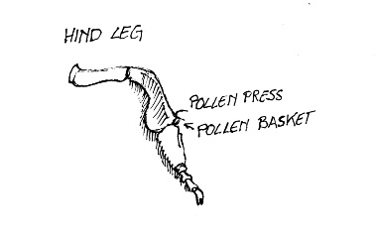

1. **Drone bee**

* It is a male bee in the hive
* It is bigger than a worker bee in the hive
* Its main work is to mate with the queen bee.
* It makes a buzzing sound
* It’s the most hairy bee in the hive
* It develops from unfertilized egg

**Simple diagram of a drone bee**

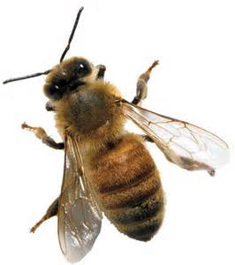

**ACTIVITY**

1. Name the three types of honey bees.
2. Give the role of the following bees
3. queen bee
4. drone bee
5. worker bees

3. Which type of bee develops from unfertilized eggs.

4. Why are worker bees unable to lay eggs?

5. Why do worker bees die soon after stinging their enemies?

6. Why do drone bees die soon after mating the queen bee?

7. How useful are pollen baskets useful to worker bees.

8. Why do bees visit flowers?

9. What name is given to special food given to queen bees?

10. Name one material bees collect from plants

**LESSON 4 AND 5**

**A swarm –** is a large cluster or group of bees

**Swarming**

* This is the massive movement of bees from one place to another looking for a better hive.

**Reasons for swarming in bees**

* When another Queen is formed
* For the queen bee to mate.
* When they are overcrowded in the hive
* When the hive is leaking or damaged
* When there is a bad smell around the hive
* Death of the Queen
* Overheating of the hive by direct sun shine
* When they are disturbed by enemies
* When there is shortage of water
* Noisy places can lead to bee swarming
* Area with a lot of smoke
* Dampness of the bee hive
* Lack of flowering plants in the area

**How to control bees from swarming?**

* By planting flowering plants near the hive
* By proper harvesting of honey from the hive
* By setting the hive under shade
* By putting the hive in a noise free place
* By protecting bees from their enemies

**Enemies of bees**

* wood ants
* safari ants
* Honey Badgers
* Pirate ants
* Hawk moths
* Wasps

**Types of bee hives**

* Traditional bee hive
* Modern bee hive

**A hive –** This is a structure where bees live.

**NB:**an apiary is a place where bee hive with bees are kept

(a) **Traditional bee hive**

This is the type of bee hive made up of local materials such as hollow logs, grass, woven sticks, cow dung, clay etc

When the bee hive is made, it is hung up in places like trees

**Examples of local hive**

* Kigezi bee-hive
* Dug out log hive
* Tin hive

**The structure of traditional bee hives**

**Advantages of traditional (local) bee hive**

* It is cheap
* It is easy to make/construct because materials are locally available

**Disadvantages of local bee hive**

* The honey collected is always dirty
* Colony cannot be inspected
* The hive is damaged when harvesting honey
* The brood is damaged when harvesting honey
* Too much honey can break the hive
* It is not durable

(b) **Modern bee hive**

**Common examples of Modern bee hive**

* Top bar hive
* Box hive

**The structure of a top bar hive**

**Chambers’ in a modern bee hive**

* brood and honey chambers
* Two chambers are separated by a metal called **Queen excluder**
* The queen excluder has holes of given sizes through which only workers pass through to look after the Queen bee

**Functions of the Queen excluder**

* The queen excluder prevents the Queen bee from laying eggs in the honey
* The queen excluder separates the brood chamber from honey chamber

**Internal structure of a modern bee-hive**

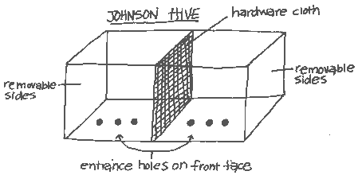

**Top bar hive Box hive**

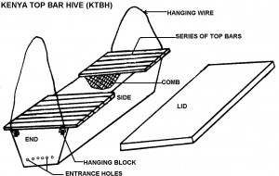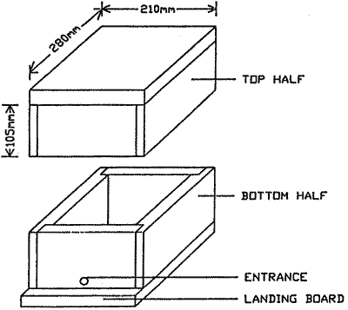

**Advantages of modern bee hive**

* The honey collected is always clean
* It is durable
* Harvesting honey is easy
* Honey and wax can be inspected easily

**Disadvantages of modern bee-hive**

* It is very expensive

ACTIVITY

1. What is swarming of bees?
2. Give any two causes of swarming of bees.
3. How can a bee keeper control swarming of bees?
4. Give any two enemies of bees.
5. Give any two ways bee keepers can protect their bees from their enemies.
6. Why should an apiary be near flowering plants?
7. Name one example of a modern bee hive.
8. How useful is queen excluder in a modern bee hive?
9. Name the two chambers of a modern bee hive
10. Give one example of a traditional bee hive.
11. Give one advantage of a modern bee hive a traditional bee hive.

LESSON 6 AND 7

**Harvesting honey**

Honey should be harvested in the evening when it is cool and all the bees have settled inside the hive

**When harvesting honey, the farmer must have the following equipment**

* A bee veil
* gloves
* A bucket
* Overall
* A smoker
* Gum boots
* Knife

**Uses of each equipment above**

**Bucket:** it is used for carrying honey combs

**Bee veil:** protects the face of a honey harvester from being stung by worker bees

**Bee keeper’s gloves:** protect hands of a honey harvester from being stung by worker bees

**Smoker:** for smoking the hive to calm the bees

**Knife:** for cutting honey combs

**Gum boots: T**o prevent worker bees from stinging the feet of a honey harvester

**Steps followed when harvesting honey**

* Smoking the hive
* Putting the hive down
* Opening the hive
* Cutting the honey combs

**A simple diagram of a farmer ready to harvest**

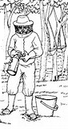

**Honey extraction**

Honey extraction is a process of separating honey from honey combs.

**Method of extracting honey**

* By floating the wax
* Centrifuging method
* Pressing the wax method

**Products got from bees**

* Honey
* Bee wax
* Royal jelly

**Uses of honey to people**

* honey is eaten as food
* It is used to sweeten tea.
* It is used as medicine for cough.
* It is a source of income when sold

NB: the food value got from honey is **carbohydrates**

**Products from bee wax**

* Wood polish
* Shoe polish
* Floor polish
* Candle wax
* Chewing gum
* Vaseline
* Crayons

**Care and management of bees**

**Siting the bee hive**. This is simply the selecting a suitable place in which to put the hive

**Factors to consider when siting hives**

* Bees should be sited away from houses, roads and animals
* Bee hives should be put in places near water sources
* Places with flowering plants
* Sheltered places
* Places with short grass

(b) **Stocking the hive**

This is a process of encouraging bees to occupy an empty hive

**It is done in various ways:**

(a) Use of a catcher box

(b) Use of a swarm catching net

(c) Smearing the inside parts of the hive with wax and honey to attract bees

**NB:**the handle of a swarm catching net can be made longer to catch a higher swarm

**A swarm catching net**

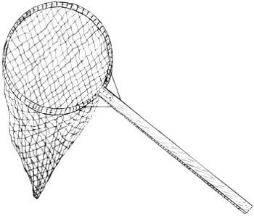

**Feeding bees**

* Bees naturally feed on nectar and pollen from flowers

ACTIVITY

1. Why is harvesting of honey commonly done in the evening.
2. Give the use of the following tools when harvesting honey
3. smoker
4. overall
5. bee veil
6. gumboots
7. knife

3. How is smoke useful to a honey harvester?

4. Name one method of extracting honey from combs.

5. Name one way of encouraging bees to occupy an empty bee hive

6. State any two products got from bee wax.

7. Give one factor to be considered when sitting a bee hive.

8. Give two uses of honey to people.

**WEEK 7**

**LESSON 1 AND 2**

**TOPIC I: KEEPING POULTRY AND BEES.**

1. How is poultry different from poultry keeping?

2. List any three examples of poultry.

3. State three reasons why farmers keep poultry.

4. What type of manure is obtained from poultry droppings?

5. Give one use of feathers got from poultry.

6. How is a beak useful to a bird?

7. Apart from using them for defense, how else are the claws to birds like chicken?

8. State any three uses of feathers to birds.

9. The diagram below shows the leg of a bird. Use it to answer questions that follow.



(a) Name the structure labelled T on the above diagram.

(b) How is structure labelled T useful to the bird?

10. Identify the type of feathers used by birds for flight.

11. Give three structural differences between a cock and a hen.

12. State two advantages of rearing local breeds of chicken.

13. Write one disadvantage of rearing local chicken.

14. How best can the quality of local breeds be improved upon?

15. Give two disadvantages of rearing exotic breeds of chicken.

16. Identify the type of chicken kept for;

(a) meat production

(b) egg production.

(c) both meat and egg production.

17. Mention any three types of feeds for chicken.

18. The diagram below shows equipment used for feeding birds. Use it to answer questions.

(a) Name the feeding equipment labelled with letters A and B.

(b) What is the use of the spinning handle on the feeding equipment A?

19. Birds have no teeth, how are they able to crush food into small particles?

20. Give two things that happen to food in the crop of a bird.

21. Define the term incubation.

22. State any one condition a fertilized egg needs in order to hatch into a chick.

23. Give three factors that may fail a fertilized egg to hatch even when favorable conditions are provided.

24. What is the incubation period of a hen’s egg?

25. Below is a diagram showing a hen’s egg. Use it to answer questions.

 K

(a) Name the parts of an egg labelled K to P

(b) What mineral salt forms part labelled K?

(c) State the function of parts L, M, and O.

L

M

O

(d) Why is part labelled K porous?

26. What major food value is obtained from eating an egg?

27. Name the two types of incubation.

28. Identify the type of incubation shown below.

..............................................................

29. What type of incubation is suitable for commercial purpose?

30. Write two advantages of natural incubation.

31. State any two disadvantages of artificial incubation.

32. What does the term brooding mean?

33. State the name given to the structure where farmers provide care to chicks below eight

weeks.

34. Mention any two types of brooders you know.

35. Why should litter be poured on the floor of the brooder where the chicks are kept?

36. How can a charcoal brooder be dangerous to chicks?

37. List any three systems of keeping poultry.

38. In which system of keeping poultry are birds left to look for their own food?

39. Give two dangers of leaving birds to look for free range system.

40. Write two advantages of rearing birds using free range system.

41. Why does the pen system need a lot of labour?

42. Give two advantages of keeping poultry using deep litter system.

43. State two uses of litter found on the floor of a deep litter house.

44. List any three materials that can be used as litter on the floor for a poultry house.

45. How can old litter from a poultry house be of use to a crop farmer?

46. Give two disadvantages of using deep litter system in rearing poultry.

47. How does deep litter system encourage vices in poultry?

48. State two dangers that can be caused by litter in a poultry house?

49. Write three advantages of battery system of keeping poultry.

50. List any four diseases that can attack poultry.

51. Mugabe’s chicken were found with the following signs; Ruffled feathers, blood stained droppings, dullness and dropping wings. What diseases were they suffering from?

52. Give one sign of gumboro disease similar to that of coccidiosis.

53. Mention three ecto parasites in poultry.

54. (a) Define poultry vices.

(b) Outline any three examples of poultry vices.

(c) State at least two causes of poultry vices.

55. Write three things that can help you to detect poultry vices in poultry.

56. Give three ways in which poultry vices can be controlled.

57. List four examples of records kept on a poultry farm.

58. State any three importance of keeping records on a farm.

59. What do we call the science of keeping honey bees?

60. Define an apiary.

61. Why are bees referred to as social insects?

62. Apart from bees, state two other examples of social insects.

63. Why are mosquitoes said to be solitary insects?

64. Name the three types of honey bees.

65. State the major duty of the queen bee in the hive.

66. What type of bees develop from unfertilized eggs?

67. Identify the kind of food fed on by the queen bee.

68. Why is it difficult to find drone bees in an established hive?

69. State the main duty of the drone bee.

70. What is meant by a wedding flight?

71. Give a reason as to why the drone bee dies soon after the wedding flight.

72. How is an ovipositor useful to a queen bee?

73. Use the diagram of a bee below to answer questions.

(a) Name the parts of a bee labelled K, L, M and N.

(b) What type of bee is shown in the diagram?

(c) State the use of the structure marked L to the bee.

(d) How is part marked N useful to the bee drawn above?

74. Why are workers bees described as sterile bees in a hive?

75. Give three of the duties of a worker bee.

76. How is propolis useful to bees?

77. Apart from nectar, mention two other things collected by worker bees.

78. Give the difference between a swarm and swarming.

79. State four reasons as to why bees swarm.

80. Mention one condition that may cause damp tress in a bee hive.

81. List any three enemies of bees.

82. How can a bee farmer protect bees against drought?

83. What type of life cycle does a bee undergo?

84. State the name given to the larva of a bee.

85. Name the two types of bee hives.

86. (a) Identify the traditional bee hive drawn below.

(b) Give one disadvantage of the above hive.

(c) Apart from the hive drawn above, give one other example of a traditional bee hive.

87. List two examples of modern bee hives.

88. The diagram below shows a top bee hive. Use it to answer questions.



(a) Name the chambers labelled T and X.

(b) Give the use of each of the chambers labelled

(i) T

(ii) X

(c) How is a queen excluder useful in a top bee hive?

(d) Give two advantages of a top bar hive over other hives.

89. Name one equipment used while stocking a hive.

90. Why should a bee hive be located far from people and animals?

91. Give the importance of locating a bee hive near flowering plants.

92. Why is evening the best time for harvesting honey?

93. List four equipment one should have when harvesting honey.

94. Why are bee harvesters advised to wear an overall while harvesting honey?

95. Give the importance of a smoker during honey harvesting.

96. What equipment is used to protect the face of a bee harvester from being stung by bees?

97. Mention the three methods used to extract honey from the combs.

98. Name the two main products obtained from bees.

99. State three uses of honey to man.

100. What food value is obtained from eating honey?

101. How can nurses make use of honey while doing their work in hospitals?

102. List three materials obtained from bee wax.

103. Give two advantages of bee keeping.

104. How is bee keeping important to crop growing?

**LESSON 3**

**TOPIC TWO: MEASUREMENT**

**Regular shaped objects**

These are objects which have a well-defined shape.

**Examples of regular objects**

Cube,

Cuboids,

Brick,

Blocks

Tins

Cylinders

Measuring regular shaped objects.

**Volume**

* Volume is the space occupied by an object.
* Volume is measured in cubic unit i.e. cubic metres, cubic centimetres or cubic millimetres.
* Volume s also measured in litres, milliliters and centiliters (cl)

**Finding volume of regular shaped objects**

The volume of regular objects like, cuboids e.g. boxes blocks bricks etc, can be found after knowing their length, width and height.

Height (H)

Length (L) width (W)

Volume = Length x width c Height

**Exercise**

1. Find the volume of the figures.
2. (b)

2cm 5cm

1cm 3cm

5cm 4cm

1. Find the volume of a brick of length 6cm width 4cm and height 3cm.
2. Find the area of a cube whose side is 3cm.

LESSON 4

**Irregular objects**

Irregular objects are objects without a well-defined shape.

**Examples of Irregular objects**

* Stones,
* Keys,
* Needles
* soda bottle
* eggs
* Irish potatoes

**Finding volume of irregular objects**

* The method of finding the volume of irregular objects is **measuring by displacement**.
* There are two instruments used in measuring by displacement i.e.

1. the measuring cylinder
2. the over flow can or eureka ca

**Using a measuring cylinder**

**Step I**

Pour water into a measuring cylinder so that it is a half full.

Record the volume of water say 30cc

**Step II**

* Get a stone and tie some thread around it
* Lower the stone into the measuring cylinder so that the stone is covered by water.
* Record the volume of water again say 35cc.

40cc 40cc

1st 30cc 30cc

2nd level

1st level

20cc 20cc

10cc 10cc

Volume of the stone = 2nd level – 1st level

= 35cc – 30cc = 5cc

The volume of water is 5cc because the amount of water displaced is always equal to the volume of the irregular object.

**Using an overflow can (eureka can)**

* Fill the overflow can with water so that the water pours out through the spout until it is at the same level of the spout.
* Put a stone whose volume you want to find and lower it into the can.
* The water will overflow and pour into the measuring cylinder.

**Find the volume of the stone by reading the level of water in the cylinder**.

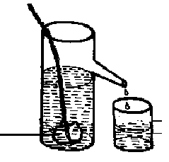

The volume of the irregular object is 10cc.

**ACTIVITY**

1. What are regular objects?
2. give one example of a regular object.
3. why is a stone called an irregular object?
4. apart from a stone give any other example of an irregular object.

5.**The diagram below shows a method of finding volume of an irregular object. Use it to answer the questions that follow**

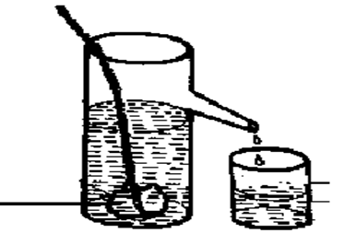stone

a) Name the method of finding the volume of the stone above.

b) What is the volume of the stone?

c). Give the use of the thread in the above experiment

d). Why is the above method used to find the volume of the stone?

6. Give the meaning of the term volume

LESSON 5 AND 6

**Capacity**

**-**Capacity is the amount of a liquid a container can hold

-Capacity is measured in liters.

NB: **Capacity** refers to amount of a liquid a container can hold while **volume** is the space occupied by a substance.

**Weight**

* Weight is the gravitational force acting on an object.

**Note**: Objects weigh less on the moon than on earth because the force of gravity is less on the moon than on earth

* **It is difficult to push a wheel barrow uphill because** you are opposing the force of gravity.
* It is easier to push a wheel barrow downhill because **you are helped by the force of gravity**.
* Weight is measured in units called Newtons.

Weight is measured using an instrument called **spring balance**

**Diagram of a spring balance**

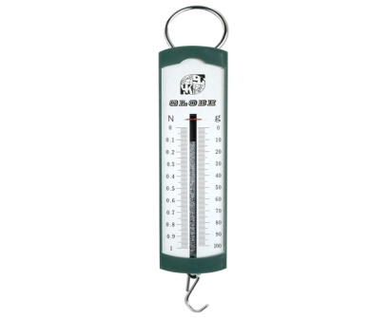

**Mass**

Mass is the quantity of matter an object contains.

Mass is constant because it doesn’t depend on the force of gravity

* Mass is measured in grammes, kilogrammes
* The basic unit for measuring mass is grammes (grams)
* The standard units for measuring mass is kilograms

**Examples of machines used for measuring mass.**

1. ***Beam balance (b) set of scale***

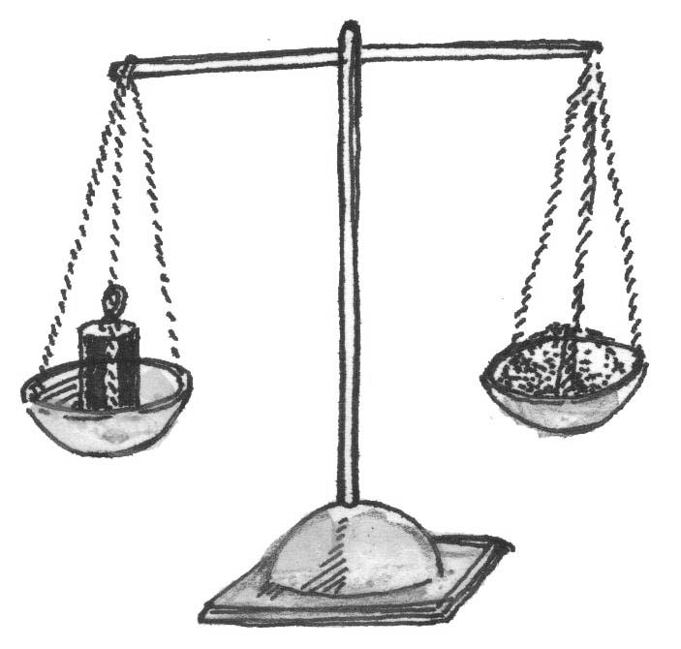 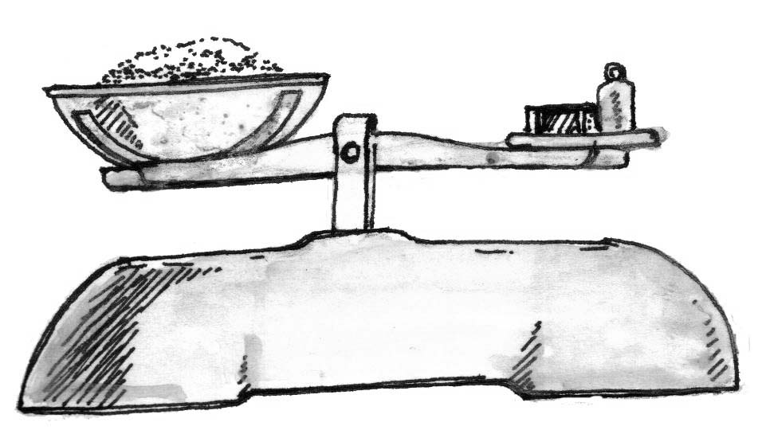

1. ***scale balance***

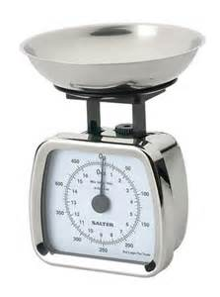

**Differences between mass and weight**

**Mass Weight**

Measured in kilograms Measured in Newtons

Measured using beam balance Measured using a spring balance

It is constant Keeps changing from place to place

**Density**

* Density is the mass of a substance per unit volume
* Density (D) = mass (M)

= Volume

D = M

V

Density is measured in grams per cubic centimetre (g/cm3)

**-A hydrometer** is an instrument used for measuring the density of different liquids

-A special instrument used for measuring density of milk is called **lactometer**

**Finding Density**

**Example I**

Find the density of an object of mass 150g and volume 3cc.

**Solution**

D = M mass = 150g

V volume = 30cc

D = 5g/cc

D = 150

30

**Example 2**

If the mass of the cuboid is 48g.

Find its density

4cm

2cm

6cm

Now, D = M mass = 480g

V volume = 48cm3

**Solution**

Here, we are not given the volume so we first find the volume

V = LxWxH

= 6x2x4

= 48cm

**Example 3**

Calculate the volume of a stone of mass 48g and density 6g/cc

Solution

We are asked to find volume

M=48g

D=6g/cc

V=M

D

48g

6g/cc

=8cc

Note: We can use the triangle below to help us to remember the formula used.

M

D V

D = M

V

M = D x V

V = M

D

**ACTIVITY**

1. Give the difference between capacity and volume
2. What is mass?
3. Name the standard unit for measuring mass.
4. Identify any one instrument used to measure mass.
5. Find the mass of an object whose density is 3g/cc and volume of 6cc
6. What is weight?
7. Name the standard unit for measuring weight.
8. Name the instrument for measuring weight.
9. Write any one difference between mass and weight.
10. Why do objects weigh less in water?
11. Why do objects weigh more on land?
12. Why do objects thrown in air fall back?
13. Find the density of a stone whose mass is 30g and volume of 5cc.
14. find the volume of an object whose mass is 25g and density 5g/ccs

LESSON 7

**Floating and sinking objects**

Floating is when an object is put in water and it stays on top of a fluid.

* Objects float on water because they are less dense than water.
* The density of water is 1g/cc and therefore, objects whose density is less than 1gg/cc float on water.

**Examples of things that float on water**

Cork, plastic, rubber, boats

Wood, sponge, a leaf, feathers etc

**Sinking**

* Sinking is when an object is put in water and it goes to the bottom of the water.
* Objects sink in water because they are denser than water.
* Objects whose density is more than 1g/cc sink in water.

**Examples**

* stones, sand, soil, metal, glass, nails etc

Note: A sinking object displaces water equal to its volume while a floating object displaces water equal to its weight

**ACTIVITY**

1. Name one object that floats on water.

2. Why does the above named object float on water?

3. Identify any one object that sinks in water.

4. Why does the above named object sink in water?

5. What factor determines the sinking and floating of objects?

WEEK EIGHT

LESSON 1 AND 2

**TOPIC II: MEASUREMENT**

1. What do we call the process of finding out how long, short, big, small, heavy or light an object is?

2. Define mass?

3. State the standard unit for measuring mass.

4. What is gravity?

5. List two units in which length is measured.

6. What is the standard unit for measuring length?

7. Mention three instruments used to measure length.

8. Define the term volume under measurement?

9. Work out the volume of the figure below.

2cm

4cm

5cm

10. A brick measures 6cm by 2cm by 3cm. calculate its volume.

11. What are irregular objects?

12. List any two examples of irregular objects.

13. Why do we use the displacement method when finding the volume of a stone?

14. When do we use the displacement method to find volume?

15. Mention two instruments used to measure the volume of irregular objects.

16. The diagram below shows a method of finding volume. Use it to answer questions. stone

(a) Identify the method of finding volume shown in the above diagram.

(b) Name the container labeled T in the diagram.

(c) What is the use of a string in the above experiment?

(d) Work out the volume of the stone as shown in the above diagram.

17. Primary five pupils carried out an experiment on finding the volume of a padlock as shown below.



(a) What method of finding volume did the pupils use in the above experiment?

(b) Name the containers labeled Land M.

(i) L

(ii) M

(c) State the name given to the part marked N on container L.

(d) What is the volume of the padlock as per the experiment above?

(e) Give a reason for your answer in (d) above.

18. Mention three machines used to measure mass.

19. State one difference between mass and weight without using definitions.

20. In which units is weight measured?

21. (a) What is meant by floating?

(b) Why do some objects float when thrown in water?

(c) List three examples of objects that can float on water.

22. Why does a needle sink when thrown in water?

23. Write any four examples of objects that can sink in water.

24. Nisha got water and paraffin and poured them in a tin. The two liquids behaved as follows.



1. Name the liquid labeled Q and R.

R

(b) Why did liquid Q float on liquid R?

Q

(c) Why did liquid R settle at the bottom of the container?

25. Find the density of an object with mass of 400gm and volume 20cc.

**LESSON 3 AND 4**

TOPIC THREE: **IMMUNIZATION**

**What is immunization**? This is the introduction of vaccines to the body to boost immunity

**Importance of immunization**

* Protect the people from acquiring immunisable diseases
* Reduce infant mortality rate.
* Enables the body to resist diseases

**Immunity**

This is the ability of the body to resist diseases

**Types of immunity**

* Natural immunity
* Artificial immunity

**Natural immunity**

**-**this is the type of immunity that is in born

**How the body acquires natural immunity?**

* Through suffering and recovering from an illness without treatment
* Through breast feeding
* Through feeding on a balanced diet

**Artificial immunity**

This is the type of immunity got through immunization

**How the body acquires artificial immunity?**

* Through immunization

**Vaccines**

Vaccines are medical drugs used for immunization

**Methods of vaccine administration**

* Oral administration
* Injection method

**Types of vaccines**

* Toxoid vaccines
* Live vaccines
* Dead vaccines

**Examples of vaccines**

BCG Vaccines

* It provides immunity against tuberculosis
* It is injected on the right upper arm at birth
* It is administered by injection method

NB: BCG in full is Bacillus Calmette Guerin

Polio vaccine

* It provides immunity against polio.
* It is administered Orally.
* Four does are given at different intervals

Measles vaccine

* It provides immunity against measles.
* It is injected on the left upper arm at nine (9 months)
* One dose of measles vaccine is applied.

Pentavalent vaccine (DPT-HepB+Hib)

* It provides immunity against Diphtheria, whooping cough, Tetanus, Hepatitis B, HaemophilusInfluenza B
* It is injected on the left upper thigh
* Three doses are given at different intervals

Note: HepB vaccine is for Hepatitis B

Hib vaccine is for Haemophilus Influenza B

DPT vaccine is for Diphtheria, Pertussis and Tetanus

**HPV Vaccine**

* **HPV in full stands** for Human Papilloma virus
* -It is used to immunize against cervical cancer.
* -It is administered to girls from9 years onwards

**Pneumococcal conjugate vaccine (PCV)**

* -It is immunized against pneumonia.
* -It is administered to babies by injection on the right upper thigh.
* -There are three doses of PCV administered to babies

**Yellow fever vaccine**

* Yellow fever vaccine is used to immunize against yellow fever
* Yellow fever is caused by a virus transmitted by a **female tiger mosquito**
* Yellow fever vaccine is administered through injection on the right upper arm

**People who should be given yellow fever vaccine**

* People who work in research laboratories
* People who travel to areas with yellow fever
* Children who are 9 months and above
* People who travel outside the country

**ACTIVITY**

1. What is immunization?
2. What is meant by the term immunity?
3. Name the two types of immunity.
4. Give one importance of immunity.
5. How does a baby get natural immunity?
6. In which way do babies get artificial immunity?
7. How is immunization important to babies?
8. Why is BCG vaccine administered at birth?
9. Identify any one oral vaccine.
10. Name one vaccine administered once.
11. Why is DPT+Hep B+Hib Vaccine called a pentavalent vaccine?
12. Why is DPT Vaccine administered at 6 weeks?
13. Why is measles vaccine administered at 9 months?
14. Why DPT Vaccine is called a triple vaccine?
15. Which vaccine is given in 4 doses?

**LESSON 5 AND 6**

**Childhood immunisable diseases**

* Measles
* Tuberculosis
* Polio
* whooping cough
* Diarrhoea
* Pneumonia
* Tetanus
* Hepatitis B
* Haemophilus influenza B
* Diphtheria
* Tetanus

**Other immunizable diseases**

* Pneumonia
* Yellow fever
* Cervical cancer
* Meningitis
* Rabies

**TUBERCULOSIS (TB)**

* It is caused by bacteria
* It attacks the respiratory system

**Signs of tuberculosis**

* chronic cough
* loss of weight
* A lot of sweating at night

**Symptoms**

* mild fever
* pain in the chest or in the upper back

**How it is spread**

* It spreads through mouth droplets.
* It can also spread through air.
* through drinking un boiled milk from an infected cow.

**Prevention and control of Tuberculosis.**

* Carry out immunization
* Treat with antibiotics
* Isolate and treat infected people.

**MEASLES**

* It is caused by a virus
* It is an air borne disease (spread through air)
* It affects the skin and the lungs

**Signs measles**

* Sores in the mouth
* runny nose
* skin rash
* dry cough
* red eyes

**Prevention of measles**

* Isolate measles victims
* Immunize children at 9 months

**Poliomyelitis (polio)**

* It is caused by a virus
* It spreads when one drinks water contaminated
* It affects bones especially the limbs.

**Signs and symptoms**

* Paralysis of the limbs
* lameness
* fever

**Prevention and control**

* Immunize children with polio vaccine.
* Drink safe clean water

**Tetanus**

* It is caused by a bacterium.
* The bacteria enter the body through fresh cuts or wounds.
* In new born babies, it can enter through the umbilical cord if it is cut with a dirty or unsterilized instrument like a razor blade.

**Signs and symptoms**

* Stiff muscles
* Spasms when touched.
* The baby stops suckling the mother’s breasts
* Lockjaw

**Prevention and control**

* Through immunization with DPT Vaccine and TT vaccine.

**Whooping cough (pertussis)**

* It is caused by bacteria and spread through air.

**Signs and symptoms**

* Coughing spells which end up in vomiting
* Gasps for breath
* Running nose

**Prevention and control**

* Immunization with DPT vaccine
* It is administered by injection on the left upper arm

**Diphtheria**

* It is caused by bacteria spread through air.

**Signs and symptoms**

* Sore throat
* swollen neck

**Haemophilus influenza type B**

This disease is caused by Virus.

**Hepatitis B**

It is caused by a virus and spreads through body contact with infected body fluids.

**Signs and symptoms**

Passing out dark urine

Nausea

Vomiting

Jaundice

Fatigue

Muscle and joint pain

**Prevention**

Immunization with HepB Vaccine.

**SUMMARY TABLE**

|  |  |  |  |  |
| --- | --- | --- | --- | --- |
| Disease | Vaccine | How it is administered | Doses | At what age |
| Tuberculosis | BCG | Injection on the right upper arm | 1 | At birth |
| Polio | Polio vaccine | Drops in the mouth | 4 | 1st dose at birth  2nd dose at 6 weeks  3rd dose at 10 weeks  4th dose at 14 weeks |
| Diphtheria  Whooping cough  Tetanus  Hepatitis – B  Influenza – B  Haemophilus | DPT-  HepB+  Hib(Pentavalent vaccine) | Injection on the left thigh | 3 | 1st dose at 6 weeks  2nd dose at 10 weeks  3rd dose at 14 weeks |
| Measles | Measles vaccines | Injection on the left upper arm | 1 | At 9 months |

**ACTIVITY**

1. What causes Tuberculosis?
2. State one way in which tuberculosis is spread.
3. Identify any one sign of tuberculosis.
4. How can tuberculosis be controlled?
5. What causes tetanus?
6. How do tetanus germs enter the body?
7. State one sign of tetanus.
8. Give one way of controlling tetanus infections.
9. Name the germ that causes measles.
10. . How is measles spread
11. Give any one sign of measles.
12. How can measles be controlled among children?
13. What causes polio?
14. Give any one sign of polio.
15. How is polio spread?
16. How can polio be controlled?

LESSON 7

**Roles of individuals,families and communities I immunization**

**Families**

* Taking their children for immunization

**Individuals**

* Helping to identify children who have not been immunized in the community
* Advising members of the community to Immunize their children
* Taking their children for immunization
* collecting information about immunization in an area using it to educate people

**Communities**

* setting up immunizationcentres
* Encouraging families to take their children for immunization
* contributing money to use on immunization
* Inviting health workers to talk to the members on immunization
* Reporting outbreak of immunisable disease in the area.

**Children**

Taking their siblings for immunization

Reminding their parents about immunization days

Helping to put up notices about immunization programmes

**Child health card**

A child health card is a document that contains the child’s bio data and immunization status.

**Importance of child health**

* Monitor the growth of a child.
* It reminds the parent the next date for immunization.
* It helps the doctor to know which dose has been given and what is remaining.

**Government and non – governmental organizations which help to carry out immunization activities in Uganda**

* Ministry of health
* UNEPI – Uganda national Expanded Programme on Immunization

**Roles of UNEPI**

To organize immunization programmes

To supply vaccines to immunization centres

Setting immunization schedules

**Activity**

1. What is immunization?
2. Define the following terms
3. Immunity
4. Anti – bodies

c). vaccines

1. Name the two types of immunity.
2. What is natural immunity?
3. Give the meaning of artificial immunity.
4. State two ways the body may acquire natural immunity
5. How does the body acquire artificial immunity?
6. State two methods of administering vaccines in the body.
7. Name any four immunisable diseases.
8. How is polio vaccine administered?
9. Name one immunisable disease administered to people at the age of 9 months.
10. Name the vaccine which provides immunity against Diphtheria, whooping and Tetanus.
11. State any two importance of a child health card.
12. Write UNEPI in full.
13. Write NIDs in full.
14. Name any two domestic animals that are vaccinated (Immunized).
15. State any two importance of immunizing people.
16. Why does immunization start at birth?
17. State the diseases whose vaccines are given more than one disease.
18. Name the vaccine administered orally.
19. Why is the first polio vaccine given to a child at the age f 6 months and not at birth?
20. Why is a measles vaccine not given soon after birth but given after nine months?

WEEK NINE

LESSON 1 AND 2

**TOPIC 3: IMMUNISATION**

1. Give the difference between immunization and immunity.

2. Name the two types of immunity.

3. Identify the type of immunity one gets;

(a) Without introducing vaccines in the body.

(b) Through receiving vaccines in the body.

4. State two ways the body receives natural immunity.

5. Mention two ways vaccines are introduced into the body.

6. Write the three types of vaccines.

7. What does T.T vaccine stand for in full form?

8. State the importance of immunity to our body.

9. In which two ways does a baby get immunity?

10. List any three of the childhood immunisable disease.

11. What childhood killer disease is prevented using BCG?

12. Name the childhood immunisable disease with these signs; red eyes, dry cough, runny

nose, skin rash and sore mouth.

13. Which body system is affected greatly by whooping cough?

14. Identify the childhood immunisable disease that causes paralysis of limbs.

15. Why are people advised to give children boiled drinking water as a way of preventing polio?

16. Name the germ that causes cholera.

17. Write two signs of cholera.

18. Why should people with cholera be given plenty of fluids?

19. Give three ways of preventing cholera.

20. Name the body organ that is affected by Hepatitis B disease.

21. The table below is all about immunization. Fill in the missing information.

|  |  |  |
| --- | --- | --- |
| **Vaccine** | **Disease** | **Immunization site** |
|  | Tuberculosis |  |
|  |  |  |
| DTP |  | Left upper thigh |
|  | Malaria |  |
| Polio vaccine | Polio |  |

22. Mention two diseases that are immunized against at birth.

23. At what age is measles vaccine first administered to children?

24. Why is diphtheria not immunized against at birth?

25. List four contents of a child health card.

26. Give one importance of a child health card to,

(a) Parents:

(b) Doctor:

27. State one role of each of the following in immunization.

(a) Individual

(b) Family

(c) Community

28. In which one way can a P.5 pupil participate in immunization programs?

LESSON 3 AND 4

**TOPIC: THE DIGESTIVE SYSTEM**

-The digestive system of human being is made up of tissues and organs which take part in the digestion of food,

-It is a system that deals with the breaking of food and its use in the body.

-The long muscular tube runs through the body from the mouth to the anus is a part of digestive system called the Alimentary canal which is 10metres long. It is where digestion of food takes place.

**DIGESTION**

This is a process by which food is broken down into soluble particles which can be absorbed into blood stream

The process by which food is taken into the body is called **ingestion**

Digestion begins in the mouth and ends in the ileum

There are two types of digestion in the alimentary canal namely:

-Mechanical digestion/ physical digestion

-Chemical digestion

**Mechanical digestion:** This is the breaking down of food into by the help of the teeth and stomach walls.

**Chemical digestion:** This is the breaking down of food into soluble substances by the help of enzymes.

**Enzymes**

Enzymes are chemical substances that speed up the digestion of food.

**Characteristics of enzymes**

* Enzymes work best under suitable temperature range
* They are destroyed by heat
* Enzymes are specific in action.
* Enzymes are proteins in nature.

**Role of enzymes**

To speed up the process digestion.

**The alimentary canal**

This is a long muscular tube along which food moves from the mouth to the anus.

**How does food move in the alimentary canal?**

Food moves along the alimentary canal through **peristalsis**

**Peristalsis** is the wave like movement of food through the alimentary canal

**Parts of the alimentary canal (tube)**

* mouth
* Gullet (oesophagus)
* stomach
* duodenum
* ileum
* colon
* rectum
* anus

**The structure of a human digestive system consists of the following parts namely:**

* mouth
* gullet (oesophagus)
* liver
* stomach
* spleen
* pancreas
* gall bladder
* bile duct
* Duodenum
* small intestine (ileum)
* large intestine (colon)
* appendix
* rectum
* Anus

**The structure of a human digestive system**

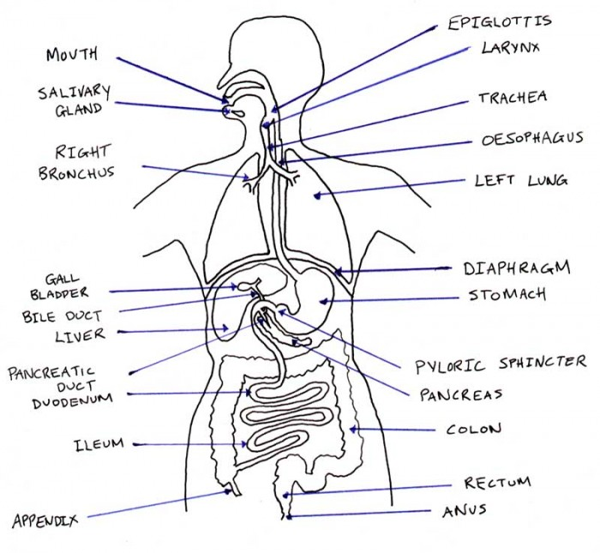

**Activity**

1. What is digestion?
2. Where does digestion of food
   1. Begin?
   2. End?
3. Name the two types of digestion in the alimentary canal.
4. What is mechanical digestion of food?
5. Name the muscular tube of digestive system that runs through the body from the mouth to the Anus.
6. Name the chemical compound that spreads the digestion of food.
7. Give one characteristic of enzymes
8. what is the role of enzymes during digestion?

**LESSON 5 AND 6**

**Digestion of food in the mouth**

**Importance of saliva during digestion**

* Saliva cools hot food
* Saliva softens food
* Saliva lubricates food

**Importance of the tongue during digestion**

* It rolls food into bolus

**Importance of the teeth during digestion**

* The teeth breakdown food

N.B *the digestive juice produced in the mouth is* ***saliva***

- The enzyme found in saliva is **salivary amylase or ptyalin**

**- Salivary amylase acts on cooked starch**

**Gullet or oesophagus**

It directs food to the stomach by peristalsis

**Simple diagrams to illustrate (Peristalsis in the Oesophagus)**

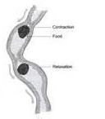

**Food in the stomach**

* The stomach stores food for a short time
* The stomach digests food
* Food is churned by the stomach turning it into **chyme**
* The stomach walls produce gastric juice

**Components of gastric juice**

* Pepsin
* rennin
* Hydrochloric acid

Pepsin acts on proteins

Rennin clots milk proteins

**Function of hydrochloric acid**

* It kills germs that escape with food to the stomach
* It provides acidic condition for pepsin to digest proteins
* It stops the action of salivary amylase
* NB 1. Absorption of alcohol, simple sugars, common salt and medicine takes place in the stomach.

2. *Chemical digestion of proteins begins in the stomach*

**Simple diagram to illustrate (The stomach)**

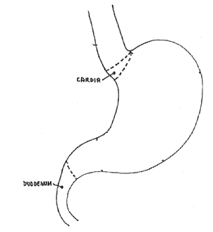

pyloric sphincter

cardiac sphincter

**ACTIVITY**

1. What is the role of the teeth during digestion?
2. Name the enzyme that acts on cooked starch in the mouth.
3. Give one use of saliva during digestion.
4. State the use of the tongue during digestion.
5. Identify the digestive juice produced in the mouth.
6. By what process does food move through the gullet?
7. Name the digestive juice produced by the stomach walls.
8. Give use of the hydrochloric acid in the stomach.
9. Give the use of the following enzymes in the stomach
10. pepsin
11. rennin

10. Identify any one substance absorbed in the stomach.

WEEK TEN

LESSON 7 AND 1

**Food in the duodenum**

It is where digestion of fats begins

It receives bile juice and pancreatic juice

Bile juice emulsifies fats

**The liver**

This produces bile juice

Bile juice is stored in the gall bladder

**The pancreas** produces pancreatic juice.

**Pancreatic juice**

This contains three enzymes

-Lipase -acts on fats

-trypsin –acts on proteins

-Amylase –acts on starch

**Food in the ileum**

Digestion of food ends in the ileum

Absorption of food takes place in the ileum

**Absorption** is a process by which digested food is taken into the blood stream.

**Adaptations of the ileum to absorbing digested food**

It has villi that absorb digested food

It has thin walls for easy diffusion of digested food

It has a network of blood capillaries transporting digested food

It is long and coiled increasing a surface area for food absorption

**The digestive juice produced in the ileum**

Succusentericus

**Class of food End product of digestion**

Proteins amino acids

Carbohydrates glucose

Fats and oils (lipids) fatty acids and glycerol

Note: Vitamins and mineral salts are not digested because they are already **soluble**

**The colon**

It is where abortion of water takes place

**Rectum**

* The rectum stores undigested food as waste matter (faeces)
* The rectum also stores worn out cells from the digestive tract.

**Anus**

- Passes out faeces

N.B the process by which undigested food is passed out the body is called **egestion**

**Importance of roughage**

It reduces the risk of getting bowel cancer.

**Activity**

1. Explain the term absorption of food?
2. Where does absorption of food take place?
3. How is the ileum adapted to food absorption?
4. Where does absorption of the following foods take place?
5. Alcohol Water
6. Digested food
7. Why doesn’t digestion of fats take place in the mouth?
8. By what process does food move down the gullet?
9. Identify the two enzymes produced in the stomach.
10. State the major function of the following parts of digestive system.
11. Gall bladder
12. liver
13. Name the enzyme that breaks down carbohydrates into maltose.
14. What is the major role of bile produced by the liver in the digestive process?
15. Identify the major function of a spleen.
16. Identify the digestive juice produced by
17. Pancreas
18. Stomach

**LESSON 2 AND 3**

**Summary table of digestive processes**

|  |  |  |  |  |
| --- | --- | --- | --- | --- |
| Organ | Gland | Digestive juice | Enzymes | Food changes |
| Mouth | Salivary glands | saliva | Ptyalin or salivary amylase | Starch to maltose |
| Stomach | Gastric glands | Gastric juice | pepsin | Proteins to peptides |
| Rennin | clot milk in babies |
| Duodenum | liver | bile | No enzyme | Emulsifies the fats |
| pancreas | Pancreatic juice | Trypsin | Proteins and peptides to amino – acids |
|  | Amylase | Starch to maltose |
|  | Lipase | fats to fatty acids and glycerol |
| Ileum |  | Intestinal juice or succusentericus | Lactase  Maltase | Lactose to glucose  Maltose to glucose |
| Sucrase | Sucrose to glucose |
| Lipase | Fats to fatty acids and glycerol |
| peptidase | Peptides to amino - acids |
| colon |  |  |  | Absorption of water |
| Rectum |  |  |  | Storage of faeces |

**Digestive disorders** (disturbance to alimentary canal and make it fail to function properly)

* constipation
* indigestion
* vomiting
* heart burn
* intestinal obstruction

**Constipation**

* This is a condition where by a person finds it difficult to pass out faeces. The faeces are very hard and dry and do not come out easily

**Causes**

* lack of roughages in the diet
* drinking too little water

**How to control constipation**

-eating food rich in roughages

-drinking plenty of safe water

**Indigestion**

* This happens when food is not properly digested
* A person feels stomach pains, heart burn (burning in the chest) and tiredness.

**Causes**

* Improper chewing of food
* Eating food hurriedly

**How to control indigestion**

* By proper chewing of food

Avoid eating food hurriedly

**Intestinal obstruction**

* Caused when intestines twist or fold themselves causes vomiting, thirst and death if not reported immediately to the doctor.

**Vomiting**

This is the expulsion of undigested food through the mouth

* This is a sign of very many diseases.
* It disturbs the digestive system and forces the cardiac sphincter to open and the food in the stomach to be ejected through the mouth.

**Diseases of the digestive system**

* Appendicitis
* Peptic ulcers
* cholera
* Typhoid
* Diarrhoea

**Appendicitis**

* This is the inflammation of the appendix.
* This may be due to stones or other indigestible solids that get trapped in the appendix.
* See the doctor for medical attention.

**Peptic ulcers**

* These are sores in the stomach wall caused by too much aid.
* The victim experiences a chronic sharp pain in the stomach and frequent heart burn.

**Dysentery**

* It is caused by a bacterium or Amoeba got by eating uncooked food or dirty food or water.
* The victim visits the toilet very frequently, passing out watery stool with some blood.

**Typhoid**

* Caused by bacteria which cause inflammation of the intestine and easily lead to death.
* It is spread through drinking contaminated water

**How to improve on the working condition of digestive system**.

* Have daily physical exercises.
* Avoid eating stale or rotten food.
* Having a balanced diet.
* Avoid drinking too much alcohol.
* Have regular meals.
* Always eat the right quantity of food.
* Avoid eating while talking.
* Drink safe clean water

**Activity**

1. Write down three diseases of digestive system.
2. Suggest any two ways through which food we eat gets contaminated.
3. Write down any two disorders of the digestive system.
4. Write down at least two examples of food eating habits.
5. Why should food be covered immediately after being oared?
6. How are house flies adapted to spreading of diseases?
7. State one way of keeping the digestive system in a proper working condition.
8. Why are vitamins and mineral salts not digested?
9. What causes constipation?
10. State one way of controlling constipation.
11. What causes indigestion?
12. State one way of controlling indigestion.

**LESSON 4 AND 5**

**TOPIC: 4 THE DIGESTIVE SYSTEM**

1. What does the term digestion mean?

2. Where does digestion of food start in the body?

3. Name the two types of digestion.

4. What breaks food into small particles while in the mouth?

5. Why is saliva mixed with food while in the mouth?

6. What rolls food into bolus?

7. The diagram below is part of the digestive system of man. Use it to answer questions that follow.

(a) Name the parts of the digestive system labeled A-G

(b) Identify the digestive juice produced at parts;

i. B : ....................................................................................................

ii. C : ....................................................................................................

iii. F : ....................................................................................................

(c) By what process does food move along part marked A?

(d) What role does part marked X play in the process of digestion?

8. State the function of the hydrochloric acid produced by the walls of the stone.

9. What digestive juice is produced in the mouth?

10. What role does the epiglottis play during swallowing of food?

11. Where in the digestive system does absorption of alcohol take place?

12. Give the function of the bile during food digestion.

13. Where does digestion of carbohydrates begin?

14. Mention two important process that take place in the ileum.

15. Why are vitamins and minerals salts not digested ?

16. In which part of the digestive system does digestion of proteins begin ?

17. Which structure in the ileum enables it to carryout food absorption?

18. Where in the alimentary canal does absorption of water and mineral salts take place?

19. How is the small intestine adapted to its function?

20. List any three disorders of the digestive system.

21. Give two of the causes of constipation.

22. In which two ways can constipation be prevented.

23. Why is it important for a young child to chew food properly before swallowing it?

24. State one cause of indigestion.

25. Mention any two systems of indigestion.

26. Write four diseases that affect the digestion system.

27. Why does dysentery cause dehydration in children?

28. Give three ways in which dysentery can be controlled.

29. How does the washing of hands before eating food help to control the spread of cholera?

30. State any two ways of keeping the digestive system in proper working conditions.

LESSON 6 AND 7

Revision in preparation for end of term exams

WEEK 11

Exams and marking of exams

Compiled by Tr. Godfrey Musisi